Final Exam Project Robotics
Obstacle Avoidance Robot with IoT Monitoring using Arduino Uno and ESP32
Member:
- Kevin heryanto (001202505027)
- Muhammad Mahasa Relung Pramardi (001202405023)
- Susi septiyani Febrian (001202405011)
- Rifky Nur Faishal (001202405012)
- Hafiz Hamidy Sugianto (001202405021)
- Alfarid Ridwan (001202405018)

- Introduction
Robotics and Internet of Things (IoT) technologies are increasingly developing and widely implemented in automation systems. This project aims to create an obstacle avoidance robot using Arduino Uno and ESP32. The robot is capable of detecting obstacles automatically and sending monitoring data through an IoT system.

The project combines robot navigation, ultrasonic sensing, servo scanning, and wireless communication into a single integrated system.

1.2 Project Objectives
The objectives of this project are:
- To build a basic autonomous robot
- To implement obstacle avoidance using ultrasonic sensors
- To integrate servo scanning for environment detection
- To establish communication between Arduino Uno and ESP32 using UART
- To display robot data through IoT communication
This project was developed and tested using the Wokwi simulation platform. The simulation environment enables collaborative development of Arduino Uno, ESP32, ultrasonic sensors, servo motors, and IoT communication without requiring physical hardware implementation.

- System Architecture
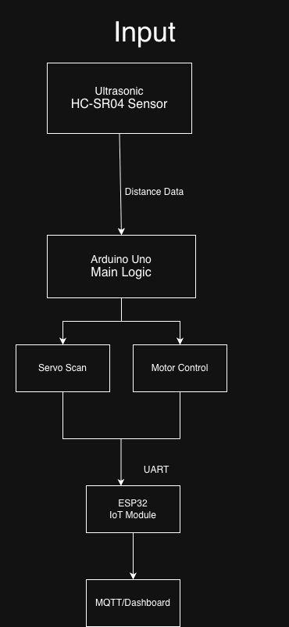
  - Arduino Uno
Arduino Uno is responsible for the main robot control system, including:

Motor control
Ultrasonic sensor processing
Servo scanning
Obstacle avoidance logic
  - ESP32
ESP32 handles the IoT communication system, including:

- WiFi connection
- MQTT / HTTP communication
- Dashboard or web output

  - Communication System
The communication between Arduino Uno and ESP32 uses UART serial communication because it is simple and easy to debug.

Example message format:
DIST=18,MODE=AUTO,TURN=LEFT
Arduino Uno sends robot status data to ESP32, then ESP32 publishes the data to the IoT dashboard or cloud service.

- Project Workflow
The project development process is divided into several stages:

- Build basic robot movement
- Forward
- Backward
- Left
- Right
- Stop
- Implement obstacle avoidance
- Detect obstacles
- Stop movement
- Move backward
- Scan left and right
- Select safe direction
- Add servo scanning system

- Develop ESP32 IoT system
- WiFi connection
- MQTT / HTTP testing
- Send dummy data

- Integrate Arduino Uno and ESP32
- UART serial communication
- Data transmission testing
- Team Task Distribution
No | Name | Responsibility
1. | Faishal | Project Lead and System Integration
2. | Kevin | Arduino Motor Control Development
3. | Mahasa | Ultrasonic Sensor and Servo Scanning
4. | Ridwan | ESP32 IoT Communication
5. | Susi | UART Communication and Testing
6. | Hafiz | Documentation, Reporting, and Final Submission

- Project Timeline
Days 1–2
- Faishal sets the system architecture, project objectives, and development deadlines.
- Kevin develops the basic robot movement functions:
- Forward
- Backward
- Left
- Right
- Stop
- Mahas performs ultrasonic sensor and servo scanning tests.
- Ridwan validates ESP32 WiFi connectivity and initial IoT setup.
- Susi designs the UART serial communication message format.
- Hafiz prepares the report template and initial wiring diagram draft.
Days 3–4
- Kevin and Mahas integrate the obstacle avoidance logic into the Arduino Uno system.
- Ridwan develops MQTT or HTTP communication output for IoT monitoring.
- Susi tests serial communication between Arduino Uno and ESP32.
- Hafiz collects screenshots, development notes, and code documentation.
- Faishal reviews overall progress to ensure all tasks remain aligned with the project objectives.
Days 5–7
- Kevin improves robot movement stability and motor tuning.
- Mahas adjusts ultrasonic scan thresholds and servo scanning accuracy.
- Ridwan finalizes the IoT dashboard and communication output.
- Susi performs stress testing for serial logs and message parsing.
- Hafiz updates the report using actual development outputs and testing documentation.
- Faishal conducts review meetings and decides feature reductions if system stability becomes an issue.
Days 8–10
All team members focus on:
- System integration
- Bug fixing
- Communication stability
- Final debugging and synchronization between Arduino Uno and ESP32
This phase emphasizes continuous progress monitoring and collaborative integration to reduce last-minute system failures.
Days 11–14
- Freeze unstable or unnecessary features to maintain project stability.
- Rehearse the final demonstration and presentation.
- Finalize the ZIP submission package and complete the final report documentation.
- Faishal approves the final integrated system.
- Hafiz prepares and organizes the final submission files and report compilation.

- Current Progress
Component | Status
Basic Robot Movement | Completed
Ultrasonic Sensor Testing | Completed
Servo Scanning System | Completed
ESP32 IoT Communication | Completed
UART Serial Communication | Integrated
Final System Integration | In Testing

- Current Challenges
Several challenges have been identified during the current development stage:
- Synchronization between Arduino Uno and ESP32
- Servo scanning stability and response accuracy
- MQTT/dashboard configuration and connectivity
- UART serial debugging and message consistency
- Integration stability between multiple subsystems

- Testing Procedure
8.1 Arduino Uno Testing

Purpose
To validate obstacle detection, servo scanning, and obstacle avoidance behavior.
Procedure
- Load the Arduino Uno simulation configuration.
- Build the project using:
pio run -e uno
- Start the Wokwi simulation.
- Adjust the HC-SR04 distance slider to less than 20 cm.
- Observe system behavior.

Expected Results
- Servo rotates to scan both directions.
- Motor status indicators change accordingly.
- Obstacle avoidance decisions are executed correctly.

8.2 ESP32 IoT Testing

Purpose
To validate WiFi connectivity, MQTT communication, and remote command handling.
Procedure
- Restore the ESP32 simulation configuration.
- Build the project using:
pio run -e esp32dev
- Start the Wokwi simulator.
- Connect an MQTT client.
- Publish the following messages:
ON
OFF
to topic:
grup2/device1/control

Expected Results
- ESP32 receives MQTT messages.
- Built-in LED turns ON when receiving "ON".
- Built-in LED turns OFF when receiving "OFF".
- Future Plan
The next development stages include:
- Finalizing IoT dashboard integration
- Improving obstacle avoidance accuracy and movement stability
- Conducting full-system integration testing
- Preparing final documentation and submission materials
- Performing final validation and debugging

- Documentation
The final report documentation will include:
- Wiring diagrams
- System architecture diagrams
- Wokwi simulation screenshots
- Serial monitor outputs
- Testing documentation
- Code explanations
- Integration workflow documentation
- Final project screenshots and demo results

- Project Limitation
Due to the limitations of the Wokwi simulation platform, full DC motor movement physics is not completely represented. Therefore, movement behavior is validated through obstacle-avoidance logic execution, UART communication, and serial monitoring outputs.

